

**PRESS RELEASE**

**FOR IMMEDIATE RELEASE drupa 2024 Hall 7a/D03**

**Global Graphics Software announces a new release of Harlequin Core, the print industry’s fastest RIP**  
  
***Harlequin Core***™ ***v14 offers unbeatable performance for modern, high-speed labels and packaging inkjet presses***

**Cambridge, UK, May 28th, 2024**: Global Graphics Software, a Hybrid Software company and developer of smart software components for print OEMs and ISVs, announces the latest release of Harlequin Core™, the print industry's fastest RIP (Raster Image Processor). Harlequin Core Version 14 represents a significant advancement in quality, performance and functionality, specifically optimized for modern high-speed digital labels and packaging presses and is fully aligned with the latest PDF standards.

“Harlequin Core v14 represents a leap forward in efficiency and capability,” says Paul Dormer, Harlequin Core product manager. “It now boasts its fastest-ever performance, with files processing up to 60% faster. Also, since Harlequin Core is now 64 bit-only and optimized for modern CPUs, users can fully exploit hardware released in the last five years."

Version 14 introduces a new feature into Harlequin VariData™ to further enhance the printing of variable data PDFs at speed. Harlequin Core now shares reusable elements across RIPs for improved performance, ensuring that RIP farm configurations benefit greatly when running on high-end multicore hardware over single RIP instances.

To achieve exceptional color reproduction, Global Graphics Software has collaborated with its sister company, ColorLogic GmbH. Leveraging ColorLogic’s world-leading expertise, Harlequin Core v14 now offers more accurate reproduction of brand colors to match real spot inks, achieved with CxF data.

Harlequin Core v14 is now easier and faster to work with a typical development environment. The QuickStart SDK (Software Development Kit) offers a library that customer code can link to directly, providing an improved Visual Studio experience. It simplifies the code structure for users integrating their own build systems, resulting in less development time. Additionally, complex InstallAnywhere distributions and platform-dependent installers have been replaced with a new distribution method using a simple ZIP file.

Harlequin Core v14 supports Mac Silicon, Windows and Linux, and is compatible with the latest print-related standards, including PDF 2.0, PDF/X-6, and PDF VT-3 specifications.

For more information, visit: [[www.globalgraphics.com/harlequin](https://www.globalgraphics.com/harlequin)](http://www.globalgraphics.com/harlequin) and see Global Graphics Software at drupa 2024 on the Hybrid Software stand: 7a/D03

ENDS

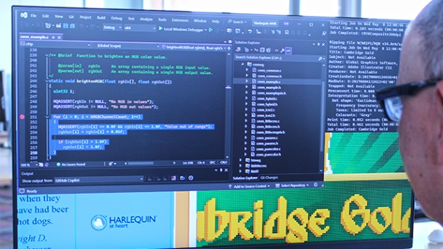

*Harlequin Core™ v14 represents a significant advancement in quality, performance*   
*and functionality, specifically optimized for modern high-speed digital labels and packaging presses.*

**About Global Graphics Software**

Global Graphics Software ([www.globalgraphics.com](http://www.globalgraphics.com)) is a leading developer of smart software components for print OEMs and independent service vendors, including [SmartDFE](https://www.globalgraphics.com/products/smartdfe/)™, [Harlequin Core](https://www.globalgraphics.com/products/harlequin/)™, [ScreenPro](https://www.globalgraphics.com/products/screenpro)™, [PrintFlat](https://www.globalgraphics.com/technologies/printflat)™ and [Mako](https://www.globalgraphics.com/products/mako)™. Customers include [HP, Canon, Durst, Roland, Kodak and Agfa](http://www.globalgraphics.com/company/customers). [The roots of the company go back to 1986](http://www.globalgraphics.com/company/history/) and to the iconic university town of Cambridge, and today much of the R&D team is still based near here. Global Graphics Software is a subsidiary of [Hybrid Software Group PLC](https://www.hybridsoftware.group/) (Euronext: HYSG).

**Media Contact**

Paula Halpin, PR & Marketing Manager, Global Graphics Software  
[Paula.halpin@globalgraphics.com](mailto:Paula.halpin@globalgraphics.com) | Tel: +44 (0)1223 926017